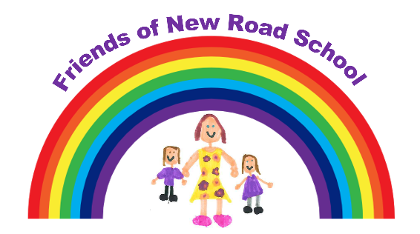

Autumn Disco Night!!
Friday 17th October 2025

KS1 – (Reception, Yr1, Yr2) – 4.15pm – 5.15pm
KS2- (Yr3, Yr4, Yr5, Yr6) – 5.30pm – 6.30pm
£3.00 per Child
Snack and drink included!

If you would like your child to attend please fill in the form and return to class teachers BY FRIDAY 10th October 2025.
Please pay via the School Gateway, all payments need to be made by Friday 10th OCTOBER (If you have not paid entry will be refused due to staff v’s child ratio)
IF SLIPS ARE NOT RETURNED BY THE DATE ABOVE NO ENTRY WILL BE ALLOWED.

IMPORTANT PLEASE NOTE:
Parents are not able to stay during the disco due to safety policy.
All children need to be dropped off and collected from school hall at stated times.
KS1 and KS2 discos are separate and cannot be mixed.
All Friends events are organised by parents and teachers in their spare time to support the school and raise money for the children. If you would like to be involved please speak to a Friends Member.
We will contact you to collect your child if behaviour is not suitable.

..…………………………………………………………………………………………………….
SLIP MUST BE RETURNED BY FRIDAY 10th OCTOBER OR NO ENTRY.

Childs Name………………………………………..…………

Childs Class……………………………………………………

Emergency Contact Number……………………………………….…

Who will be collecting the child………………………………………

Special Dietary Requirements……………………………………….

